Machine Description | A deliberately vulnerable lab machine for practicing web app exploits, privilege escalation, and post-exploitation to gain user and root access.
Target IP | 192.168.0.114
Vulnerability Name | - Outdated Linux Kernel  - Privilege Escalation via Local Exploit  - Vulnerable utempter Package  - Missing Security Patches  - Misconfigured/Weak Server Hardening
Port / Service | TCP 443 / http
Severity | High 7.4
Attack Vetor | CVSS:3.0/AV:L/AC:H/PR:N/UI:N/S:U/C:H/I:H/A:H
Proof of Concept (PoC) | STEP 1 – Nmap to find the IP of the target machine.  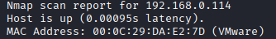  STEP 2 – Nmap Scan to discover open ports and Services  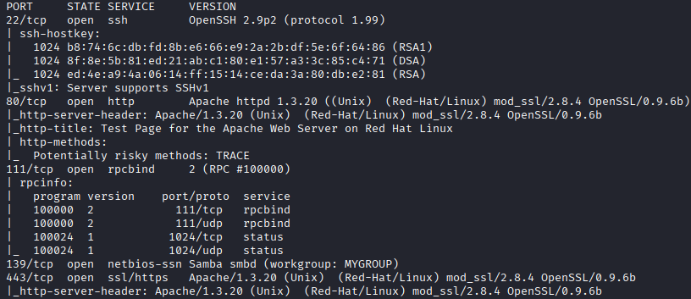  # nmap –p- -sC –sV $ip –open  STEP 3 - Found an exploit (exploit name - 21671.c)  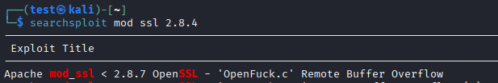  STEP 4 – We have to first compile it  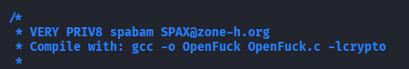  STEP 5 - Complied the exploit    STEP 6 - Executed it  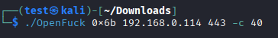  STEP 7 – We have a shell  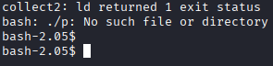  STEP 8 - Found utempter as a GUID  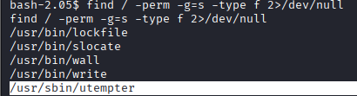  STEP 9 - Found the Kernal version  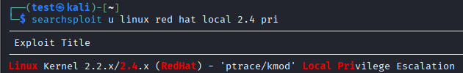  STEP 10 – Found a Privillage escalation exploit (exploit name – 3.c)  STEP 11 - Transfer the exploit and complied it and gave it executable permissions  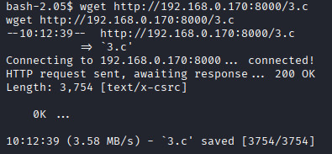  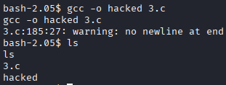  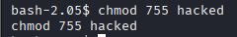  STEP 12 - Executed it and we have root  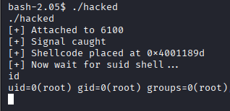  PROOF:  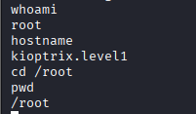
Remediation | • Update Linux kernel to the latest stable version.  • Apply all system and security patches regularly.  • Update/remove vulnerable packages like utempter.  • Disable unnecessary services and binaries.  • Implement proper system hardening (permissions, file access).  • Use intrusion detection & monitoring for exploit attempts
Impact | • Attackers can run exploits to gain shell access.  • Privilege escalation allows full ROOT control.  • Complete system takeover (read, modify, delete files).  • Installation of malware or backdoors.  • Loss of confidentiality, integrity, and availability.
References | https://www.linuxsec.net/kernel  https://owasp.org/www-community/attacks/Privilege_Escalation  https://linuxhint.com/linux_hardening_basics

